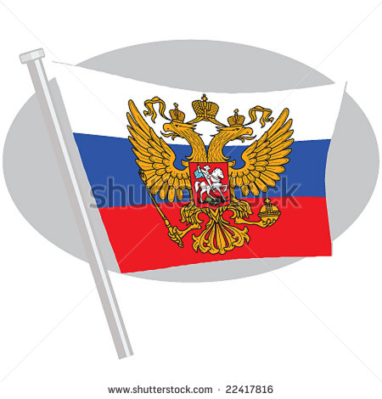

**Tsar Nicholas II is facing a number of challenges. You are his trusted advisor and he is looking to you for answers to his problems. Analyze the problems facing Nicholas and give him your best advice to save Russia**

|  |  |
| --- | --- |
| **Event** | **Your Advice** |
| *Russia is a very large nation without much industry. Its natural resources are spread across huge distances. How can you make reaching the resources easier and build factories?* |  |
| *Russia is still under the feudal system. Peasants are still serfs and not free to make their own choices. Will you side with the wealthy nobles or the downtrodden serfs?* |  |
| *Your son is very sickly. You have learned of a priest who can possibly help him. The priest is not liked or trusted by most Russians. Will you let the priest come to try and help your son?* |  |
| *Russia is in the midst of a famine and there is high unemployment. How will you deal with the starving and unemployed people?* |  |
| *Germany attacks Serbia, an ally of yours. Germany is not as big as Russia, but its military is much more advanced. Russia’s military will take a long time to prepare. Should you help defend Serbia, your ally?* |  |
| *Many workers go on strike. Industry and business are crippled. This only makes the famine and unemployment worse. What will you do with those who are refusing to work?* |  |